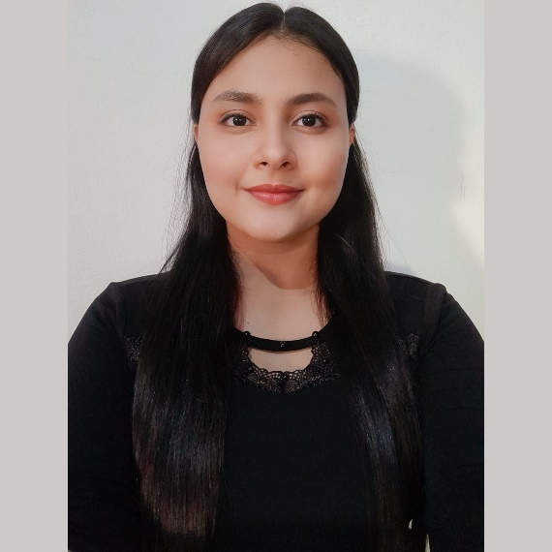

I respect.

Responsibility.

Trust.

hostess.

Loyalty.

Sincerity.

Commitment.

Equity.

Tolerance.

**SKILLS**

**PROFESSIONAL VALUES:**

Good communication

office automation

Teamwork

Methodology and good practices

Project Management and Testing

3D and 2D Three-Dimensional Animation

**EDUCATION**

**Middle education**

*National Institute of Santa Elena (INSE)*

Title: Vocational Technical Baccalaureate option accounting.

2017 – 2019

**Higher Education (In formation process)**

*Gerardo Barrios University (UGB).*

Title: Engineer in Computer Systems and Networks

2020 – 2025

**LANGUAGES**

Native Spanish

**POST:**

Integrate into a work team, contributing with my knowledge and skills, acquired throughout my educational and professional training, in order to function with ease and commitment in business and personal development.

**AIM:**

RELATIONIST.

Member of the AEOCOMPU student association, he participated in social projects, in order to help people and live with them.

**Phone:**+503 7548-9465.

**Location:**Colonia Jardines de la Constancia, Santa Maria, Usulután.

**Email:**

lety280917@gmail.com

**GUERRERO**

I am a student of the Computer Systems and Networks Engineering career, from the Gerardo Barrios University, from the science and technology faculty, I am currently 21 years old, I have knowledge in: Office automation, teamwork,project management and testing, 3D and 2D three-dimensional animation.

**ABOUT ME:**

**Project manager.**

**LETICIA**

**CONTACT**

Excel